**Bangabandhu Sheikh Mujibur Rahman Science & Technology University,**

**Gopalganj-8100**



**Project Report on**

**“Social Media Project”**

**Jamil Rayhan**

Computer Science & Engineering

ID: 18CSE061

Session: 2018-19

Department of Computer Science & Engineering,

Bangabandhu Sheikh Mujibur Rahman Science and Technology University. Gopalganj, Bangladesh

**“Social Media Project”**

Submitted to the Department of Computer Science and Engineering (CSE), in partial fulfillment to the requirements for the degree of 3rd year second semester.

Submitted By

**Jamil Rayhan**

Computer Science & Engineering

ID: 18CSE061

Session: 2018-19

Supervised By

**Md. Monowar Hossain**

Assistant Professor

Department of Computer Science and Engineering

Faculty of Engineering

Bangabandhu Sheikh Mujibur Rahman Science and Technology University,

Gopalganj – 8100

**CERTIFICATE OF COMPLETION**

Student’s Name: Jamil Rayhan

Student’s ID: 18CSE061

Project Title: **Social Media**

I certify that this project “**Social Media**” is the original work of the above-named candidate and has been done under my supervision. The work has never been submitted anywhere. It’s only submitted to Bangabandhu Sheikh Mujibur Rahman Science and Technology University. I am the undersigned, recommend that the project completed by the student listed above, in partial fulfillment of B.Sc. Engineering degree requirements, be accepted by the Department of Computer Science and Engineering, Bangabandhu Sheikh Mujibur Rahman Science and Technology University for deposit.

**Supervisor Approval\***

………………………………..

**MD. MONOWAR HOSSAIN**

Assistant Professor,

Department of Computer Science & Engineering

Bangabandhu Sheikh Mujibur Rahman Science & Technology University

Gopalganj-8100

**ACKNOWLEDGEMENT**

I would like to express my sincere gratitude to my supervisor **MD. MONOWAR HOSSAIN**, Assistant Professor, Department of Computer Science & Engineering, Bangabandhu Sheikh Mujibur Rahman Science and Technology University, Gopalganj, Bangladesh. For providing me with invaluable guidance, comments, and suggestions throughout the course of the project.

I perceive this as a good opportunity for my career development.

I am very grateful to the great creator for letting me to complete the project.

Sincerely,

JamilRayhan

Computer Science & Engineering

ID: **18CSE061**

Session: 2018-19

**ABSTRACT**

The social media project aimed to develop a robust and user-friendly web application that fosters digital connectivity and community engagement. The platform was designed to offer a seamless and interactive experience for users to connect, communicate, and share various forms of content with their social circles. The project focused on incorporating modern technologies, efficient database management, and intuitive user interfaces to create a compelling and dynamic social networking experience.

The key features of the social media platform included user registration and authentication, personalized user profiles, news feed with real-time updates, the ability to post text, images, as well as commenting and liking functionalities. Advanced algorithms were implemented to tailor the user's feed based on their interests and interactions.

In addition to the core functionalities, the project emphasized user privacy and security by implementing robust encryption protocols, secure data storage, and stringent access controls. Furthermore, the platform integrated user reporting mechanisms and moderation tools to ensure a safe and inclusive online environment.

Throughout the development process, agile methodologies were adopted to allow for iterative improvements based on user feedback and changing requirements. The platform was designed to be scalable, capable of handling a growing user base and increasing amounts of content.

The project successfully delivered a fully functional social media platform that catered to users' social and communication needs while adhering to the highest standards of data privacy and security. The platform demonstrated excellent performance and responsiveness, providing a seamless user experience across various devices and screen sizes.

Table of Contents

1. Introduction: 1

1.1 Executive Summary: 1

1.2 Introduction: 1

1.3 Objectives: 1

1.4 Target Audience: 1

1.5 Project Overview: 1

Scope: 1

Technology Stack: 2

Project Timeline: 2

1.6 Motivation & Aims: 2

1.7 Objectives: 3

2. System Analysis: 3

2.1 System Environment: 3

2.2 Software Requirement Specification: 3

3. System Design: 4

3.1 Features of the Project: 4

3.2 Data Flow Diagram: 5

3.3 ER Diagram 5

4. Procedure 6

4.1 Some Screen Shot of Running Project 6

5. Limitations and future plan 16

5.1 Limitations: 16

5.2 Future Plan: 17

6. Conclusion 17

7. Reference 18

List of Figures

Figure.1: ‘0’ Level DFD. 5

Figure.2: ER Diagram 5

Figure.3: Sign up Page. 6

Figure.4: Home Page. 6

Figure.5: Like Comments Buttons 7

Figure.6: Post View Page. 7

Figure.7: Post Search Result. 8

Figure.8: User Search Result. 8

Figure.9: Inbox Page. 9

Figure.10: Conversation View. 9

Figure.11: Notification Page. 10

Figure.12: Profile Page. 10

Figure.13: Edit Profile. 11

Figure.14: Post Box. 11

Figure.15: Follower List. 12

Figure.16: Following List. 12

Figure.17: Edit or Delete Post. 13

Figure.18: Edit Post Page. 13

Figure.19: Other User Profile. 14

Figure.20: Other User Profile After Follow. 14

Figure.21: First Time Message Page. 15

Figure.23: Login Page. 16

# 1. Introduction:

## 1.1 Executive Summary:

The Social Media project aims to create a cutting-edge social media platform that will revolutionize how individuals connect and engage with others online. The platform's primary objectives include fostering meaningful connections, promoting user-generated content, and delivering a seamless and enjoyable user experience. By leveraging advanced technologies and user-centric design principles, the project seeks to cater to a wide range of users and provide a dynamic and engaging platform.

## 1.2 Introduction:

Project Background: In an increasingly digital world, social media platforms have become essential for communication, networking, and content sharing. Our project seeks to address the need for a modern and user-friendly social media platform that prioritizes user experience and community-building.

## 1.3 Objectives:

The project's core objectives are as follows:

* Create a user-friendly platform that encourages meaningful interactions and connections.
* Empower users to share and consume diverse and engaging content.
* Implement state-of-the-art security measures to protect user data and privacy.
* Introduce innovative features that differentiate the platform from existing competitors.

## 1.4 Target Audience:

The platform aims to cater to a diverse audience, including individuals of all age groups, interests, and backgrounds. By offering features that resonate with various demographics, the platform seeks to create an inclusive and vibrant community.

## 1.5 Project Overview:

Scope: The project's scope encompasses the development of a web-based social media platform and a corresponding mobile application. Key features include user registration and authentication, profile creation, post sharing, social interactions, personalized recommendations, and notifications.

Technology Stack: The platform's development will be based on the following technologies:

* Backend: Django framework with Python programming language.
* Frontend: HTML, CSS, Bootstrap for dynamic and responsive user interfaces.
* Database: SQLite database for efficient data storage and retrieval.

Project Timeline: The project will be executed in multiple phases, each with specific milestones. The estimated timeline includes design and planning, development, testing, and deployment.

## 1.6 Motivation & Aims:

The motivation behind undertaking the Social Media project stems from recognizing the growing significance of social media in today's digital age. Social media platforms have become integral to modern communication, networking, and content sharing. However, existing platforms may not fully cater to diverse user needs or provide the optimal user experience.

The primary aims of the Social Media project are as follows:

* Innovation and Uniqueness: The platform will offer a unique and engaging user experience that fosters meaningful connections and interactions.
* User-Centric Design: The platform aims to be intuitive, accessible, and responsive, catering to users of all ages and backgrounds.
* Safe and Secure Environment: We aim to implement robust security measures to protect user data and prevent unauthorized access.
* Content Diversity and Engagement: The platform will encourage users to share diverse and creative content, including photos, videos, and written posts.
* Monetization and Sustainability: The project aims to establish a sustainable business model by incorporating various monetization strategies, such as targeted advertising, sponsored content, and premium features.
* Scalability and Growth: Anticipating a growing user base, the platform will be designed for scalability and efficient handling of increased traffic.
* User Feedback and Iterations: We value user feedback as a crucial aspect of our project.

## 1.7 Objectives:

The objectives of the Social Media Platform project are to develop a user-friendly and secure platform that enables seamless user registration and authentication. Users will have the ability to create and manage personalized profiles, share various types of content, and engage in social interactions with other users. The platform will provide personalized news feeds and recommendations, real-time notifications, and robust data privacy measures. A responsive and intuitive user interface will enhance the overall user experience. The project will explore monetization strategies for sustainable revenue generation and focus on scalability and performance optimization to accommodate a growing user base. User feedback and continuous improvement will drive ongoing enhancements and user satisfaction.

# 2. System Analysis:

## 2.1 System Environment:

The system environment analysis is a critical aspect of the Social Media project, as it involves assessing the technological landscape and infrastructure required to develop and deploy the platform. This phase involves the following key activities:

* Technology Stack Evaluation: Evaluating and selecting the appropriate technology stack, including programming languages, frameworks, and databases, based on the project's requirements and objectives.
* Server and Hosting: Identifying the best hosting solution that can support the platform's expected user traffic, ensuring optimal performance and reliability.
* Scalability Assessment: Analyzing the platform's scalability to accommodate increasing user numbers and data volumes in the future.

## 2.2 Software Requirement Specification:

The Software Requirement Specification (SRS) document defines the detailed requirements of the Social Media Platform. It serves as a blueprint for the development, providing a clear understanding of the project's scope and functionalities. The SRS includes:

1. Functional Requirements: Describing the specific features and functionalities that the platform must offer, such as user registration, profile creation, post sharing, social interactions, and notifications.
2. Non-Functional Requirements: Outlining the performance, security, and usability requirements, such as response time, data encryption, and accessibility
3. Use Cases: Describing various user scenarios and interactions with the platform to understand the flow of actions and user journeys.
4. Data Model: Defining the database schema and data entities required to store user information, posts, comments, and other relevant data.
5. Constraints and Assumptions: Identifying any constraints, limitations, or assumptions that may impact the project's development and implementation.
6. User Interface Design: Presenting wireframes and mockups of the user interface to visualize the platform's design and layout.

# 3. System Design:

## 3.1 Features of the Project:

The Social Media Platform project offers a wide range of features that aim to create a dynamic and engaging user experience. Key features of the platform include:

* User Registration and Authentication: Users can sign up for the platform using their email or social media accounts. The platform ensures secure authentication and login processes.
* User Profile Creation: Users can create and manage their profiles by adding personal information, profile pictures, and cover photos. They can also set privacy settings to control the visibility of their information.
* Post Creation: Users can create and share posts, including photos and text. They can add captions and hashtags to enhance post visibility.
* Social Interactions: The platform enables social interactions between users, such as following other users, liking and commenting on posts, and sending direct messages.
* News Feed and Recommendations: Users receive personalized news feeds based on their interests and interactions. The platform also provides recommendations for new connections and content.
* Notifications and Activity Tracking: Users receive real-time notifications for new followers, likes, comments, and mentions. The platform tracks user activity, such as post views and profile visits.
* Privacy and Security: The platform prioritizes data privacy and implements security measures to protect user information and prevent unauthorized access.

## 3.2 Data Flow Diagram:

|  |
| --- |
| Register |

|  |
| --- |
| Results of Query/Reports |

USER

Admin

# Figure.1: ‘0’ Level DFD.

|  |
| --- |
|  |

|  |
| --- |
|  |

## 3.3 ER Diagram

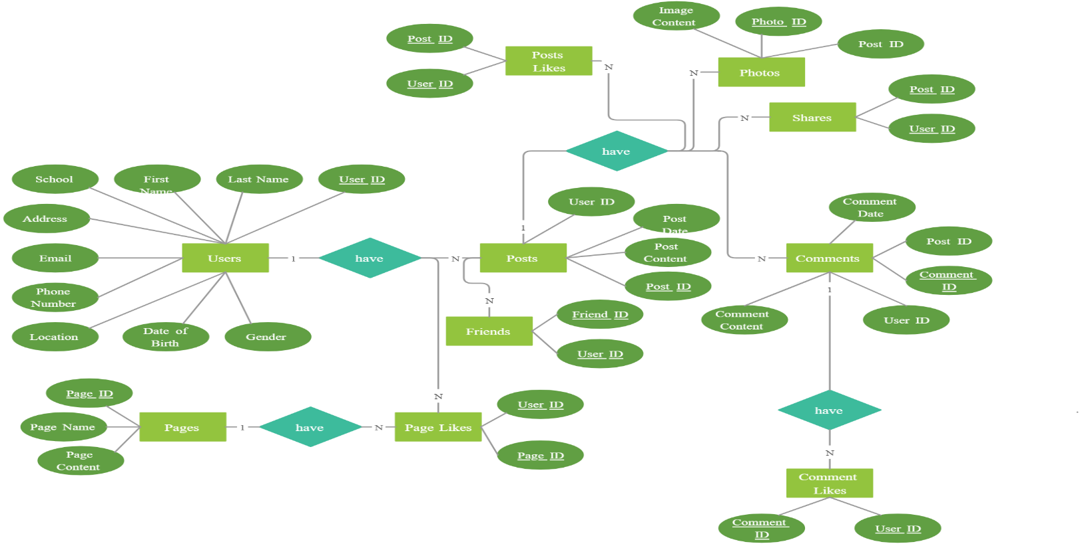

Figure.2: ER Diagram

# 4. Procedure

## 4.1 Some Screen Shot of Running Project

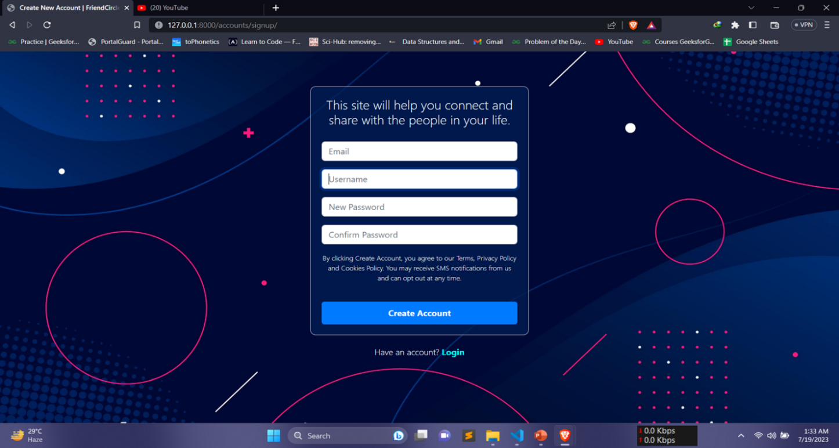

# Figure.3: Sign up Page.

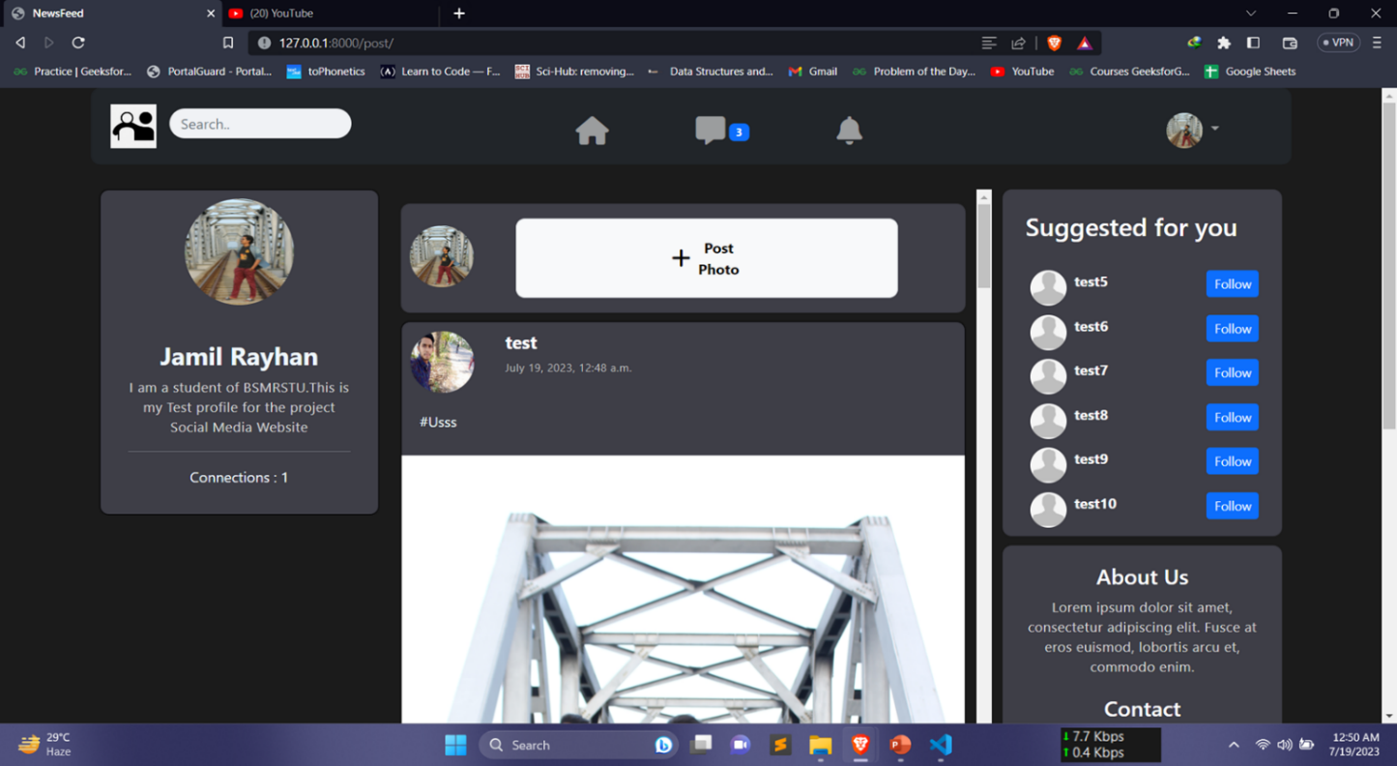

# Figure.4: Home Page.

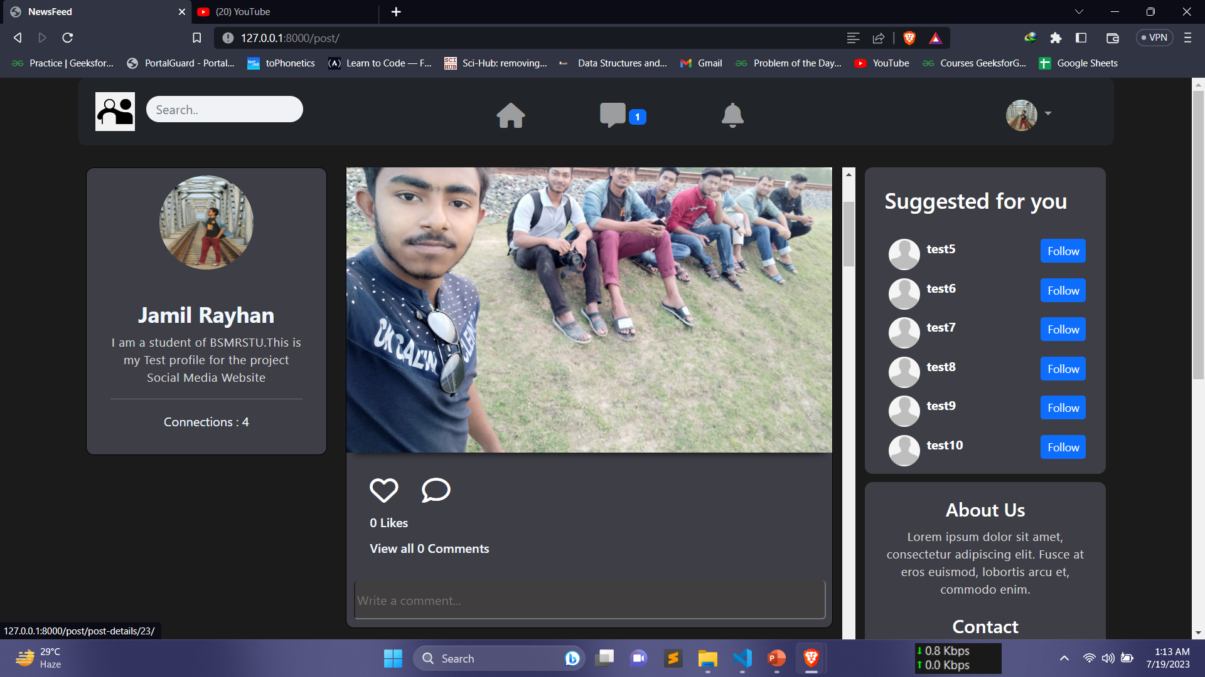

# Figure.5: Like Comments Buttons

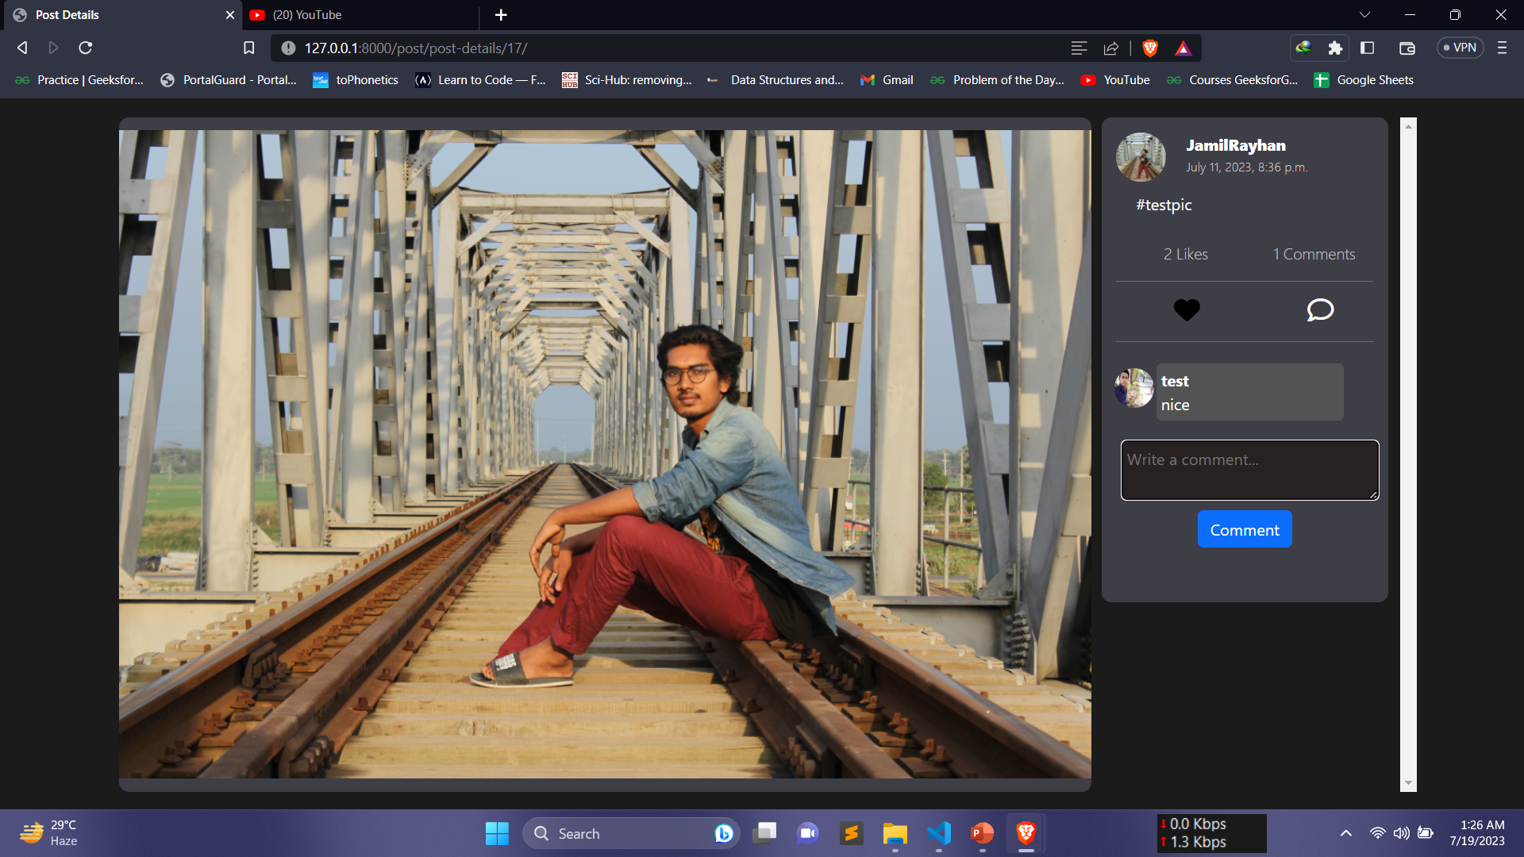

# Figure.6: Post View Page.

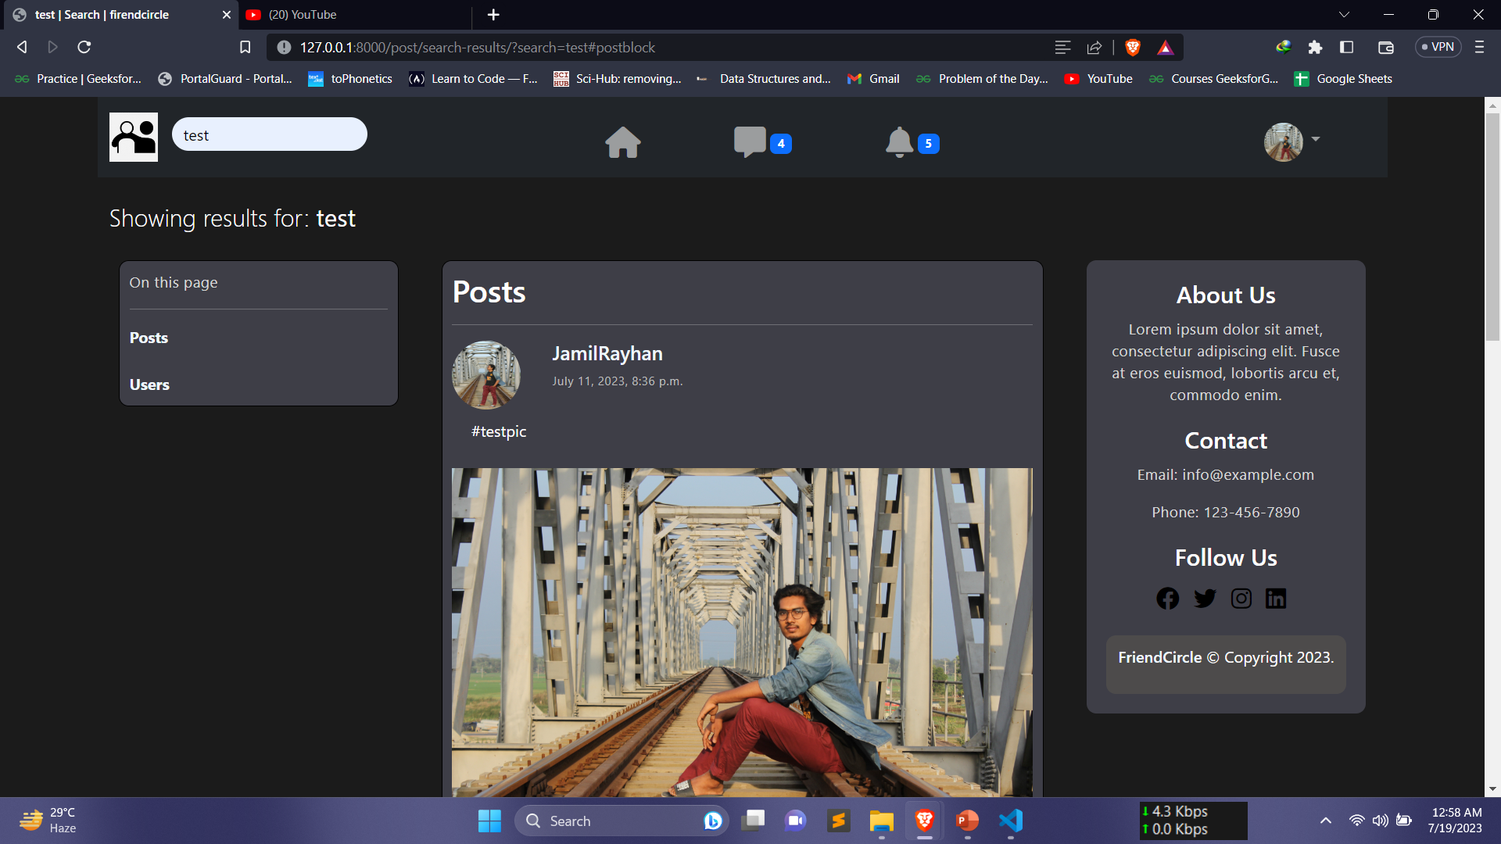

Figure.7: Post Search Result.

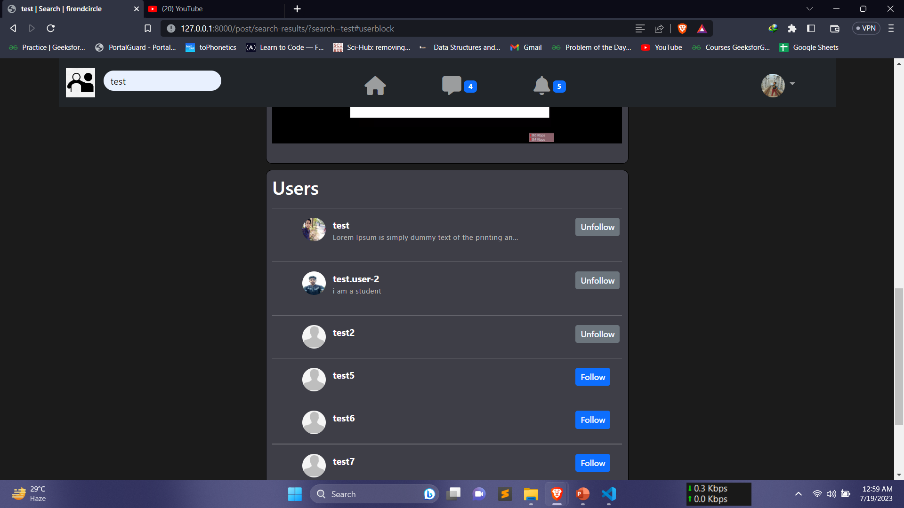

# Figure.8: User Search Result.

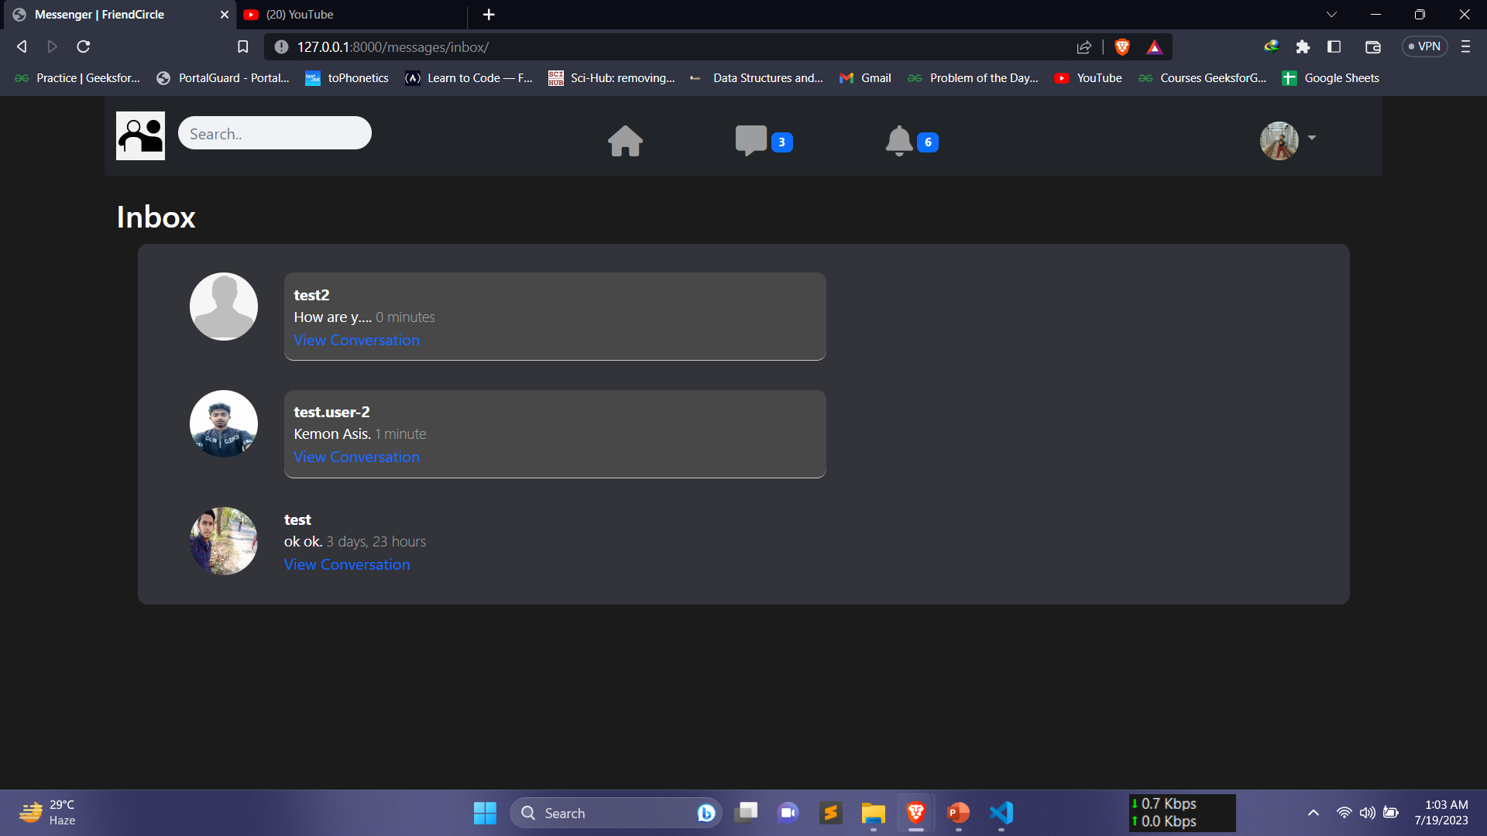

# Figure.9: Inbox Page.

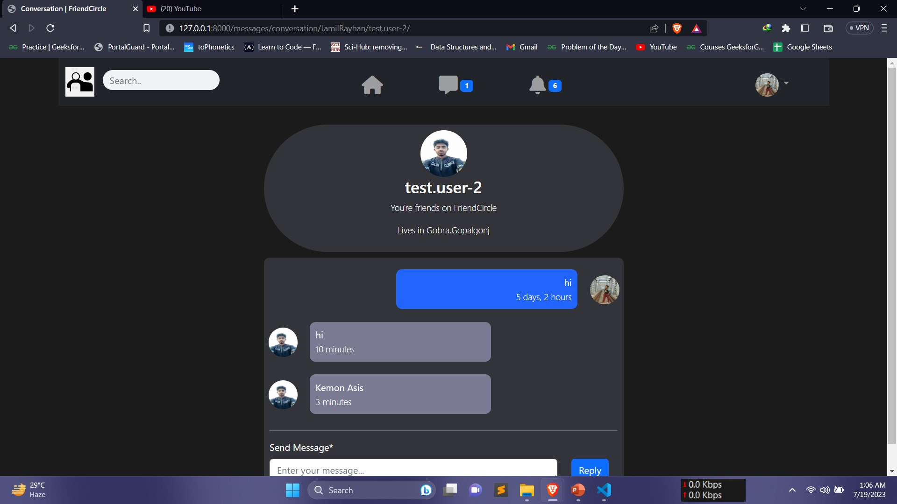

# Figure.10: Conversation View.

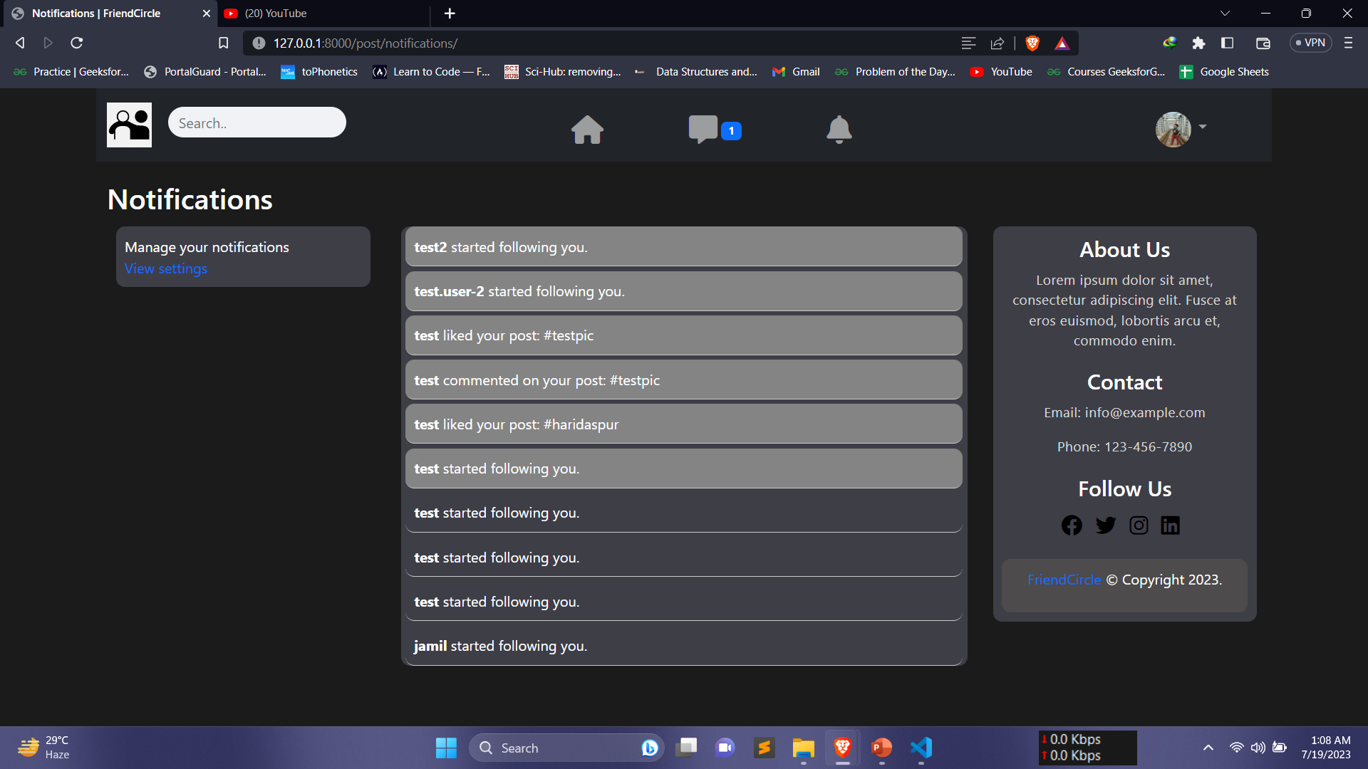

# Figure.11: Notification Page.

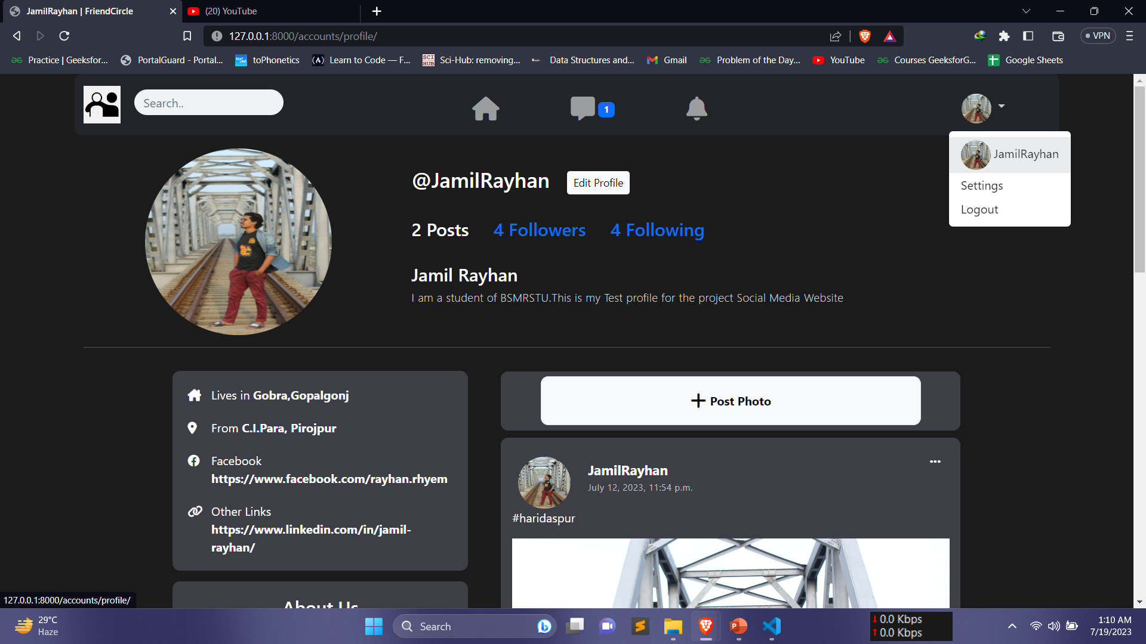

# Figure.12: Profile Page.

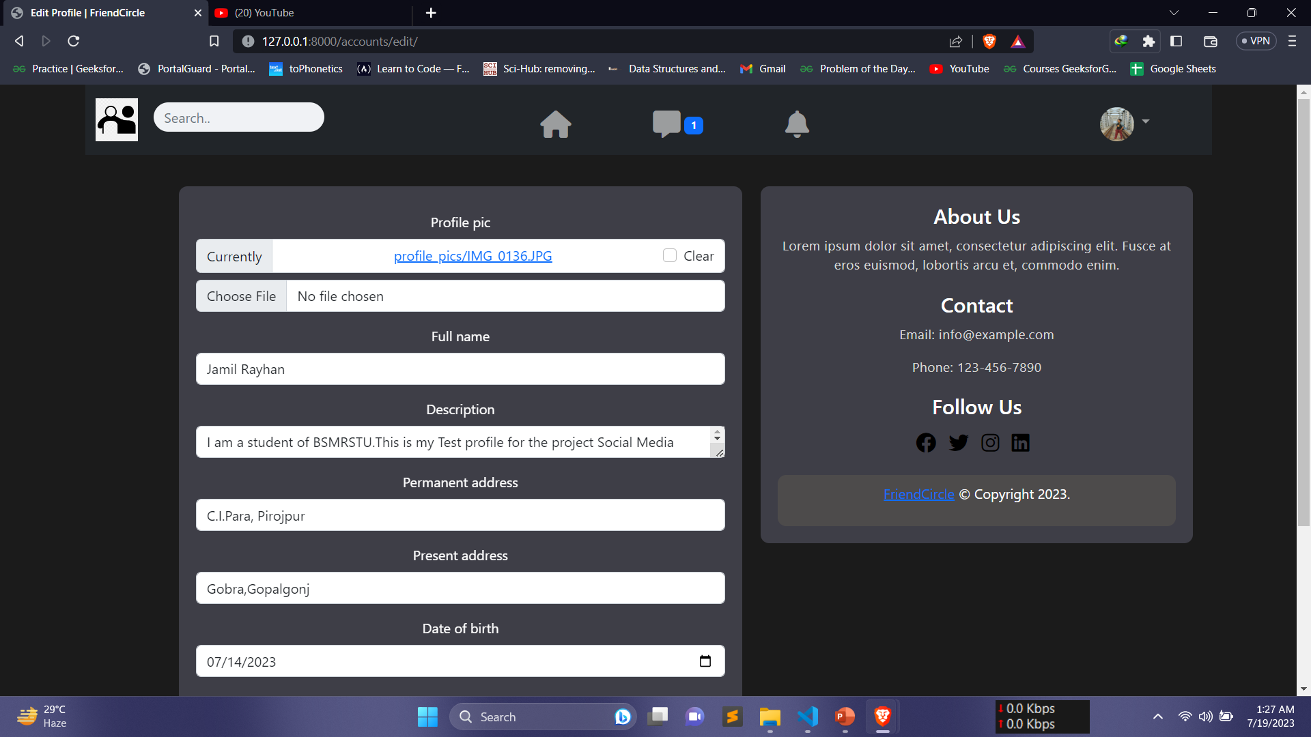

# Figure.13: Edit Profile.

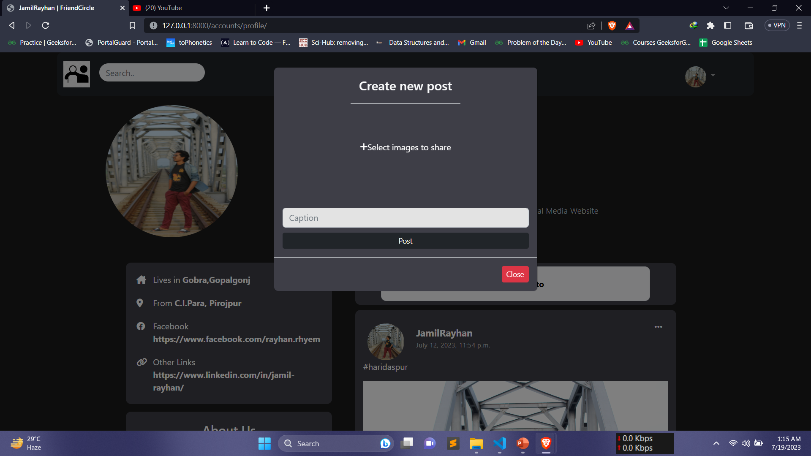

# Figure.14: Post Box.

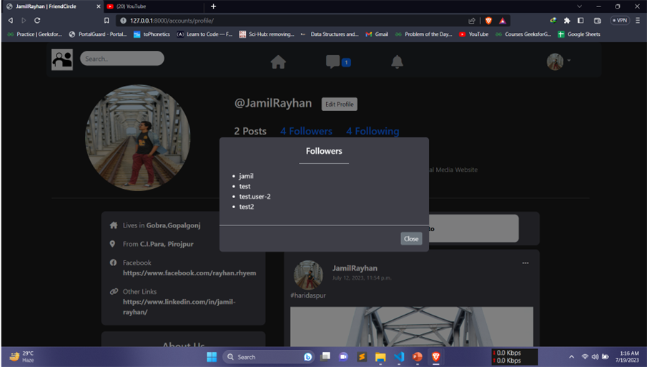

# Figure.15: Follower List.

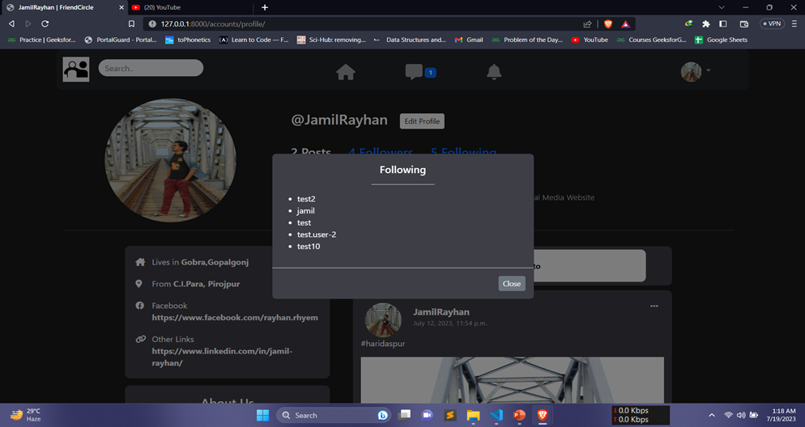

# Figure.16: Following List.

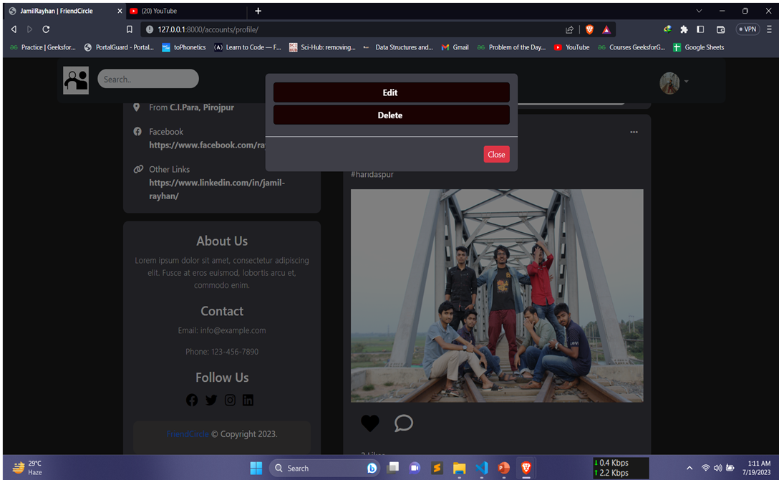

# Figure.17: Edit or Delete Post.

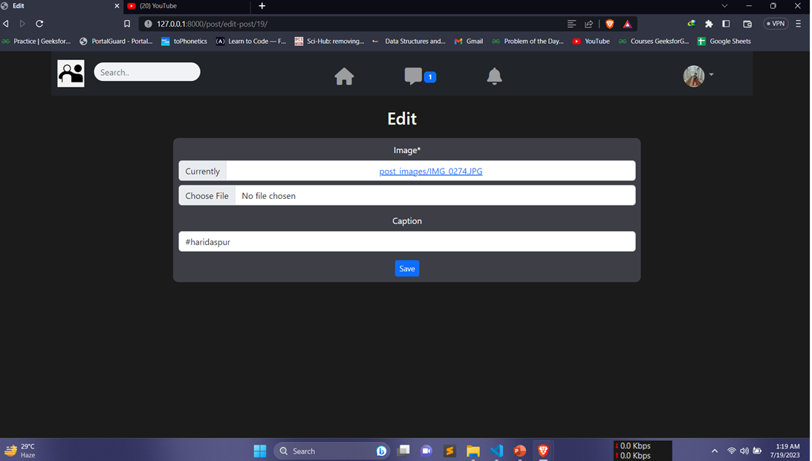

# Figure.18: Edit Post Page.

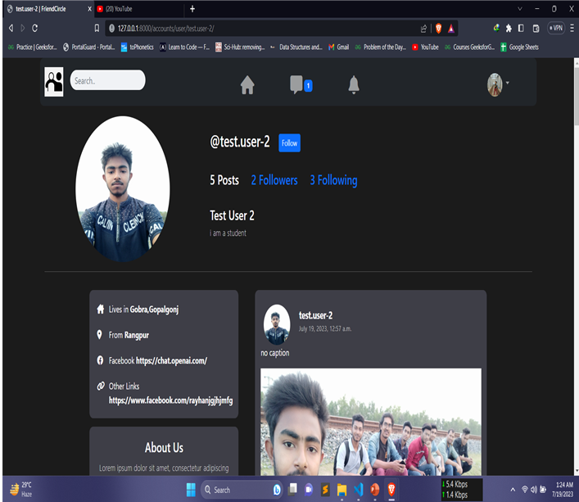

# Figure.19: Other User Profile.

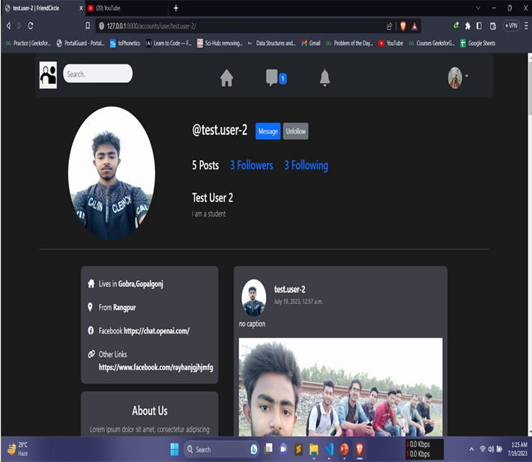

# Figure.20: Other User Profile After Follow.

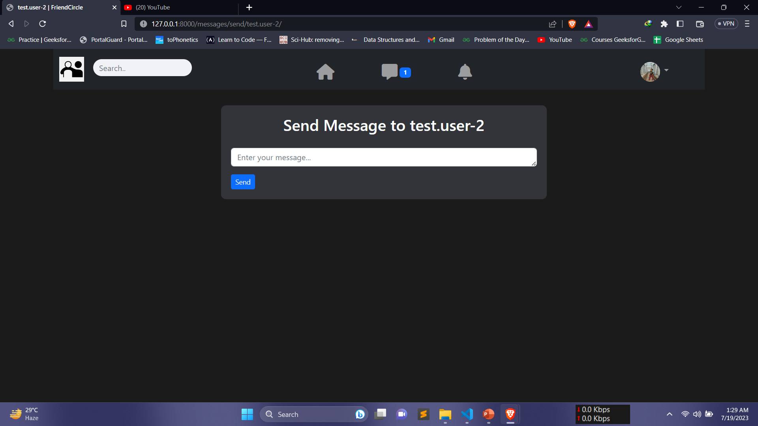

# Figure.21: First Time Message Page.

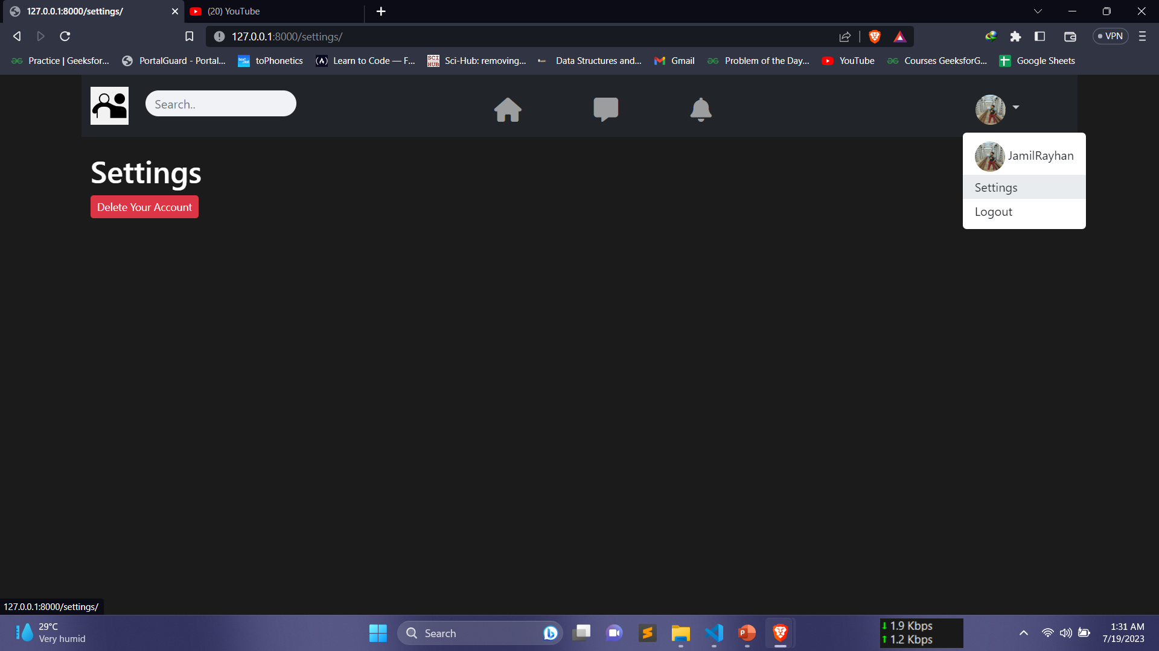

Figure.22: Settings

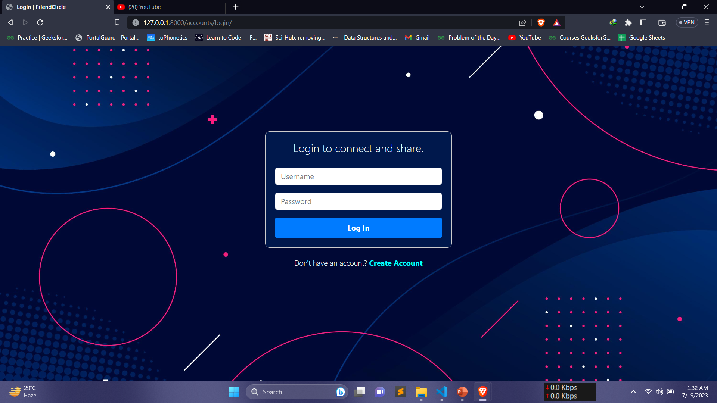

# Figure.23: Login Page

# 5. Limitations and future plan

## 5.1 Limitations:

1. Scalability: While the current system is designed to handle a moderate user base, it may face scalability challenges as the platform attracts a larger audience. Ensuring smooth performance and quick response times during peak loads will be crucial.
2. Data Privacy and Security: Protecting user data and ensuring data privacy is an ongoing concern. Compliance with evolving data protection regulations and constant vigilance against security threats will be essential.
3. Monetization Challenges: Implementing successful monetization strategies, such as targeted advertising and premium features, may require careful market analysis and user feedback to strike the right balance between revenue generation and user experience.
4. Competition: The social media landscape is highly competitive, and attracting and retaining users in the face of well-established platforms will be a challenge.

## 5.2 Future Plan:

1. Enhanced Features: Continuously enhancing the platform by introducing new and innovative features will be vital to keep users engaged. Features like live streaming, advanced search, and interactive filters will be explored.
2. Internationalization: Expanding the platform's reach by incorporating multi-language support and localization features to cater to a global audience.
3. Advanced Analytics: Implementing robust analytics tools to gain valuable insights into user behavior and preferences, enabling personalized content recommendations and targeted advertising.
4. Integration with External Platforms: Integrating the platform with other popular social media platforms and external services to enhance user convenience and cross-platform engagement.
5. Augmented Reality (AR) Integration: Exploring AR technology to offer unique and interactive user experiences, such as AR filters and virtual events.
6. User-Centric Approach: Continuously collecting and analyzing user feedback to drive iterative improvements and enhancements based on user needs and preferences.
7. Partnerships and Collaborations: Collaborating with influencers, brands, and content creators to foster user engagement through sponsored content and partnerships.

# 6. Conclusion

The Social Media Platform project holds immense potential to create a vibrant and connected online community. Despite the challenges and limitations, the platform's robust features, security measures, and scalability plan set a strong foundation for future growth and success. With a user-centric approach and continuous innovation, the platform is poised to make a meaningful impact on users' lives and thrive in the dynamic social media landscape.

# 7. Reference

1. Django. (n.d.). Django Web Framework. Retrieved from <https://www.djangoproject.com/>
2. Django Rest Framework. (n.d.). Django Rest Framework. Retrieved from <https://www.django-rest-framework.org/>
3. Bootstrap. (n.d.). Bootstrap - The Most Popular HTML, CSS, and JS Library. Retrieved from <https://getbootstrap.com/>
4. Crispy Forms. (n.d.). Django Crispy Forms. Retrieved from <https://django-crispy-forms.readthedocs.io/>
5. OpenAI. (n.d.). GPT-3.5. Retrieved from <https://openai.com/>
6. GitHub. (n.d.). GitHub. Retrieved from <https://github.com/>
7. Pexels. (n.d.). Free Stock Photos & Videos. Retrieved from <https://www.pexels.com/>
8. Unsplash. (n.d.). Beautiful Free Images & Pictures. Retrieved from <https://unsplash.com/>
9. Pixabay. (n.d.). Stunning Free Images & Royalty Free Stock. Retrieved from <https://pixabay.com/>

Note: The above references are used for the development and documentation of the Social Media Platform project. These resources have been valuable in learning and implementing various features, tools, and technologies to create a successful social media platform.